Practical 1.1:-

Step 1: Search google docs

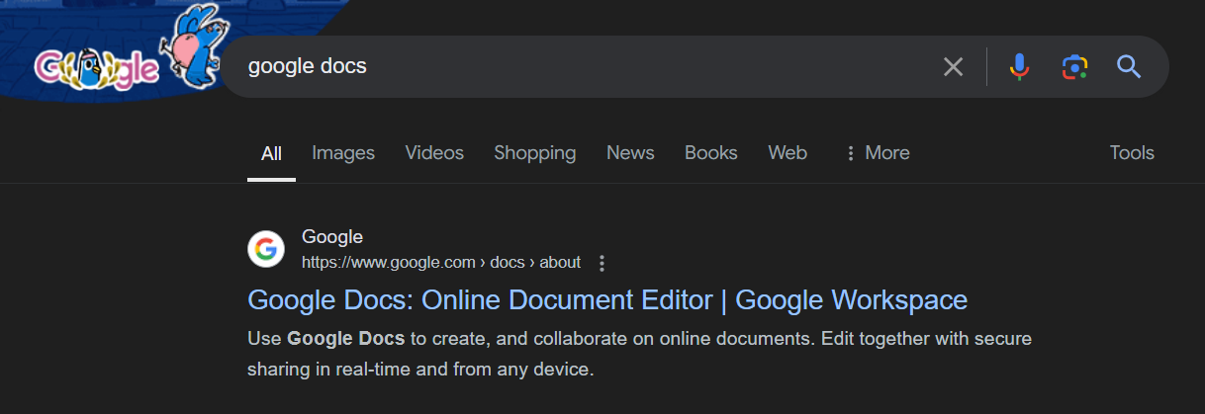

Step 2: Open it and write a random paragraph

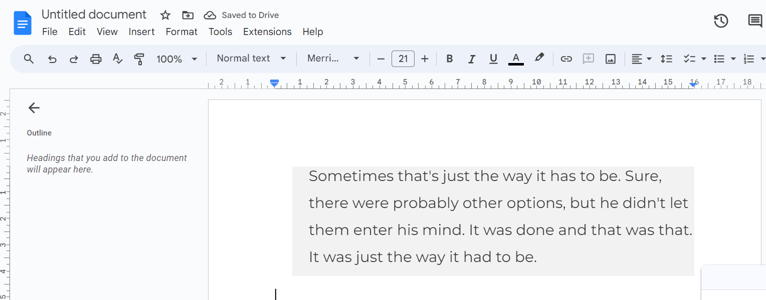

Step 3: Save it in my drive

